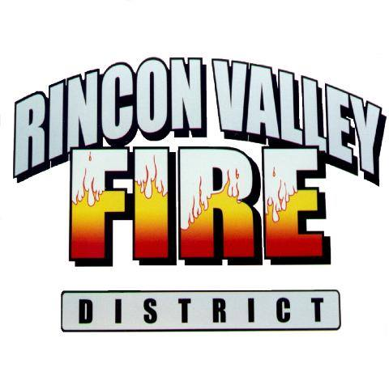
Rincon Valley Fire District
14550 E. Sands Ranch Rd.
Vail Arizona 85641
(520) 647-3760 / FAX (520) 647-7102
Fire Marshal Jacqueline Bisnar

DEVELOPERS, CONSTRUCTION SUPERVISORS, SUBCONTRACTORS

CONSTRUCTION JOB SITE FIRE SAFETY GUIDE

This Construction Job Site Fire Safety Guide is Published and Provided by the Rincon Valley Fire District Fire and Life Safety Division as a Customer Service to the Construction and Design Community

CONSTRUCTION JOB SITE

FIRE SAFETY GUIDE

Welcome to the Rincon Valley
Fire District

INTRODUCTION

This guide is provided by the Rincon Valley Fire District (RVFD) Fire and Life Safety Division as a service to the construction and design community to assist you with completing your project.

This guide is not all inclusive. A pre-construction meeting is typically required through for most projects. Reviewing this document and attending a pre-construction meeting may divert costly changes or requirements pertaining to your project.

SCOPE

The purpose of the publication is to provide information regarding frequently asked fire code questions and issues that are applicable to construction sites. Additionally, the guide provides important inspection and testing information, forms and Certificate of Occupancy requirements that will assist the fire inspector in completing an inspection. This in turn will assist you with finishing your project. Finally, this document will provide you with important safety information during times of construction or demolition.

The goal is to achieve compliance with the Rincon Valley Fire District’s Fire Code requirements and amendments by partnering and assisting you with the completion of your project within your deadlines. In order to be successful in this endeavor, communication is critical. If you communicate your issues to the assigned Fire Inspector, an early solution will generally be worked out that satisfies everyone.
Your project will be assigned to an inspector. Ideally, you should interact with the same inspector throughout the life of the project. However, occasionally, your assigned inspector may not be available, due to scheduling or emergencies. In those cases, another qualified inspector will be assigned to conduct the inspection, which should not cause a delay in the completion of your project.

Your cooperation in observing these regulations and making those responsible aware of the safety requirements outlined, will be greatly appreciated as well as minimize the possibility of delays or problems with your project.

If you have any questions, please contact the Fire and Life Safety Division at 520-647-3760.

TABLE OF CONTENTS

HEADING PAGE

Adopted Fire Code 4
General Information 4
General Contractor 4
Fire Protection Contractor 4
Construction Trailers 5
Fire Apparatus Access Roads 6
Fire Hydrants 8
Combustible Waste 9
Fire Extinguishers 9
Heaters 10
Asphalt Kettles 10
Hot Work 11
Knox Box 12
Gates 13
Fire Lane Signs 16
Address 16
Warming Fires 17
Storage and Use of Flammable Liquids 18
Compressed or Liquefied Gas Storage 18
Generators 19
Fire Inspection and Testing 20
Sprinkler Systems 22
Fire Alarm Systems 26
Kitchen Extinguishing Systems 27
Certificate of Occupancy 28

FIRE SAFETY DURING CONSTRUCTION, ALTERATION OR DEMOLITION OF A BUILDING

APPROVED PLANS AND PERMITS MUST BE ON THE JOB SITE DURING CONSTRUCTION AND SYSTEM TESTING

Adopted Fire Code and Amendments

The Rincon Valley Fire District has adopted the International Fire Code (IFC) with local amendments supported by NFPA standards as referenced in the IFC, Chapter 80. Please contact the Fire and Life Safety Division at 520-647-3760 for information on the current edition of the adopted codes, amendments and standards or visit the web site www.rinconvalleyfd.org

General Information

Fire safety during construction, alteration, or demolition of a building is critical for the safety of job site employees, fire inspection personnel, fire fighters and the general public. The following is a general outline of preconstruction requirements and specific information pertaining to each requirement.

General Contractor

The General Contractor is responsible for the fire safety of all property under their control. Therefore, the General Contractor will ultimately be held responsible for any fire code violations that may occur on the job site. The General Contractor is responsible for maintaining copies of all permits, inspection reports and approved stamped plans on the job site.

Fire Detection And Suppression Systems Contractor

The Fire Detection/Alarm Contractor is responsible for maintaining the approved set of fire protection system plans on site, scheduling inspections and coordinating with the General Contractor or Superintendent.

The Fire Suppression/Sprinkler Contractor is responsible for maintaining the approved set of fire suppression plans on site, scheduling inspections and coordinating with the General Contractor or Superintendent.

In addition, the Fire Suppression or Detection/Alarm Contractor is responsible for verifying the system is ready (pre-tested) for inspection, which includes verifying that the system was installed according to approved plan(s), prior to calling for any inspection.

Construction / Sales Trailer
(May Require Fire Permit Prior To Construction)

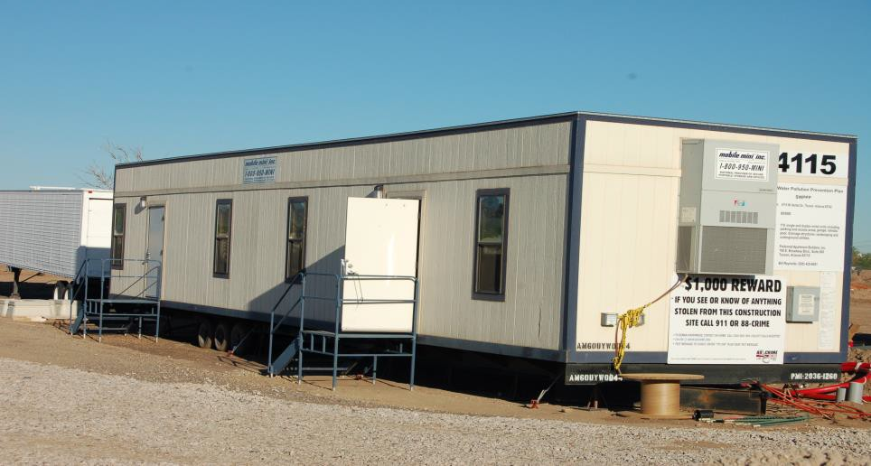

A building permit may be required for a temporary construction/sales trailer from Pima County Building Safety Division depending on the jurisdiction of your project. A fire sprinkler or fire alarm system is not required for temporary construction/sales trailers (not to exceed 90 days). A fire hydrant, providing the required fire-flow, shall be made available within 500 feet of the trailer prior to the arrival of the construction trailer.

When the construction/sales trailer is equipped with a fire suppression or fire detection system, a permit is required for the installation of the systems. Fire inspection acceptance testing is required. Fire protection systems must be maintained while the trailer is on site.

When the trailer utilizes a gas or diesel powered generator using flammable or combustible liquids, a fire permit may be required. Please see Section 12; “Generators Utilizing Flammable/Combustible Liquids”, for specific details on fire application/permit, prior to placing the generator in service.

Fire Apparatus Access Roads

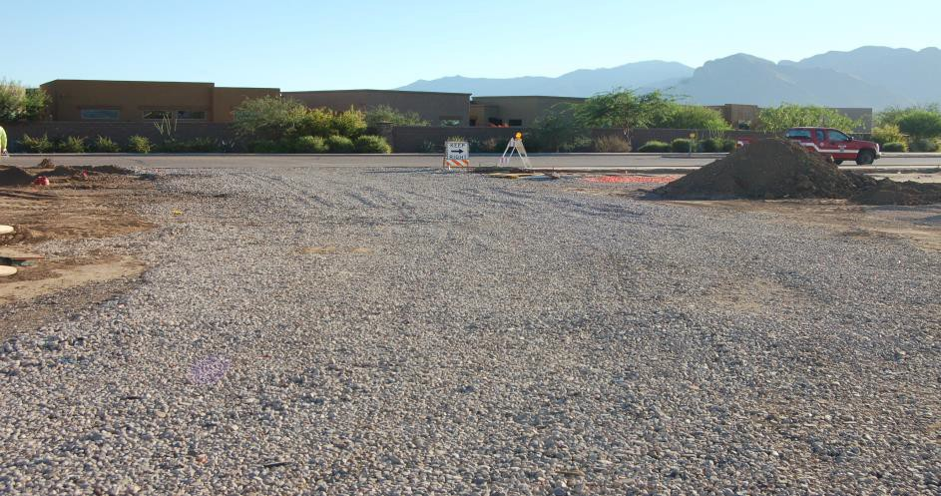
Fire apparatus access roads shall be required and maintained throughout construction to allow emergency response vehicles onto the construction site for fire, emergency medical services, and technical rescue situations.

All access roads shall be a minimum of 20 feet wide, 13 feet 6 inches vertical clearance, with an approved turn-around for lanes traversing 150 feet or longer. A variety of turn-around designs can be found in the IFC. These include 96’ diameter cul-de-sacs, 120’ hammerheads, 60’ wyes and 70’ pockets. Buildings 30 feet or more in height require two (2) fire access roads which are at least 26 feet in width.

Fire apparatus access roads shall extend to within 150 feet of all portions of the facility and all portions of the exterior walls of the first story of the building as measured by an approved route around the exterior of the building.

Fire apparatus access roads shall be in place prior to combustible construction materials being brought onto the site or prior to start of vertical construction, and combustible debris storage areas, whichever comes first. Fire apparatus access roads shall not be obstructed in any manner, including the parking of vehicles.

In some cases, depending on the circumstances, access roads may be required at an earlier stage of the project.

Temporary Access - During Construction

During construction, temporary access roads may be approved when in compliance with the following minimum requirements:
- The fire apparatus access road shall be an all weather driving surface, graded to drain standing water and engineered to bear the imposed loads of fire apparatus when roads are wet. The minimum surface shall consist of six inches thick ABC compacted to 90 % over an approved base and shall support the minimum weight of 82,000 pounds. Compaction test results shall be provided to the Fire Inspector prior to approval.

- Alternate methods may be approved when designed and sealed by a Professional Engineer registered by the State of Arizona and approved by the Fire District.
- The Contractor or person in charge of any construction site for a commercial building, where structures total more than 4,000 square feet, shall provide and maintain fire lanes as shown on approved site plans. Fire lanes shall be constructed of asphalt, concrete or other alternative materials pre-approved by the Fire Marshal, sufficient to support fire apparatus as follows:
Concrete: 41ton weight limit required (82,000 lbs)
Asphalt: 41 ton weight limit required (82,000 lbs)
Gravel: 41-ton weight limit required (82,000 lbs),
minimum one (1) inch rock and six (6) inches deep with underlay approved by Fire Marshal on a compacted sub-grade or a minimum six (6) inches of Aggregate Base Course (ABC) compacted to 90% over an approved base and graded so that “ponding” does not occur after rainfall.

Temporary or permanent access roads

Temporary or permanent access roads shall be capable of supporting vehicle loading under all weather conditions. Vehicle access shall be maintained until permanent fire apparatus access roads are available.

- Alternate methods may be approved when designed and sealed by a professional engineer and approved by the Fire District.
- All open trenches cut across any fire apparatus access road shall be provided at all times with steel plates capable of maintaining the integrity of the fire apparatus access road design and must be filled in and resurfaced by the end of the working day.
- The edges of the access road shall be obvious or clearly marked. In cases where markings are not practical or possible or markings are not visible, curbing shall be installed.
- Each site should have a minimum of two access points into the site unless approved by the RVFD Fire Marshal. The access points shall be a minimum of 20 feet in width and shall be maintained accessible at all times
- Additionally, all fire apparatus access roads shall be provided with a drive through access or have an approved turn-around per Rincon Valley Fire District Standard Detail as found in the IFC Appendix D
- All fire apparatus access roads shall be clearly marked at the entrance with an approved sign approximately four feet by four feet in size. The lettering shall be red on a white background which states, “EMERGENCY ACCESS ROAD” and shall include the address of the site and contact information. If appropriate, the use of arrows may be approved by the Fire Inspector. Additional access road markings may be required throughout the project as warranted

FIRE HYDRANTS

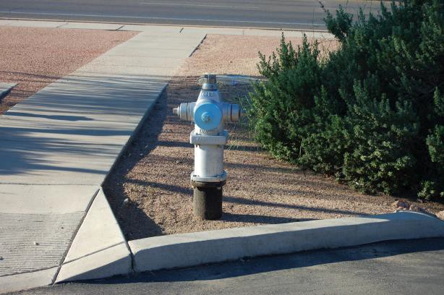
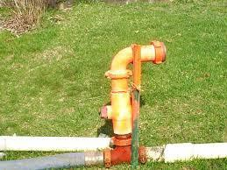

Fire hydrants shall be in place and operational prior to combustible construction materials being brought onto the site. Operational means being fully tested, chlorinated, and approved by the Water Department and RVFD. A hydrant shall be located within 150 feet of stored combustible construction materials. Additional hydrants shall be installed in accordance with the Pima County requirements and IFC Appendix C.

The use of temporary piping and hydrant systems, while discouraged, is acceptable provided the hydrant can operate at the required flow rate. Plans for such a system must be submitted and approved by RVFD prior to installation.

There are a number of common errors possible with respect to the installation of new fire hydrants. Most have to do with variations between preliminary grading designs and final grading. Others involve specific uses of areas near where hydrants are installed. If these issues are not monitored, hydrants can end up being situated in such a manner that they, at best, look strange and, at worst, are difficult or impossible to operate.

Hydrant installation details need to be coordinated among all parties involved at the construction site. If hydrants are being installed in areas to be landscaped or if final grading elevations are not clear, the specified hydrant design should easily accommodate placement of riser extensions of various lengths so that the final hydrant installation is compatible with the final grade elevation.

As a general rule, no equipment, vegetation or facilities should be within 3 feet (1m) of the hydrant body, or placed in front of any hydrant outlet, nor be placed between the hydrant and the roadway. Those persons who are landscaping near hydrants should be apprised of these conditions as walls, plants and other landscape materials must be kept outside the hydrant's clearance space.

The center of a hose outlet shall be not less than 18 inches (457 mm) above final grade, or when located in a hose house, 12 inches (305 mm) above the floor.

Hydrants shall be protected if subject to mechanical damage. Protection shall be arranged in a manner that will not interfere with the connection to, or operation of, hydrants.

VEHICLE IMPACT PROTECTION

Vehicle impact protection required by the IFC shall be provided by posts that comply with the following:
- Constructed of steel not less than 4 inches (102 mm) in diameter and concrete filled
- Spaced not more than 4 feet (1219 mm) between posts on center
- Set not less than 3 feet (914 mm) deep in a concrete footing of not less than a 15-inch (381 mm) diameter
- Set with the top of the posts not less than 3 feet (914 mm) above ground
- Located not less than 3 feet (914 mm) from the protected object

Physical barriers other than posts shall be a minimum of 36 inches (914 mm) in height and shall resist a force of 12,000 pounds (53, 375 N) applied 36 inches (914 mm) above the adjacent ground surface.

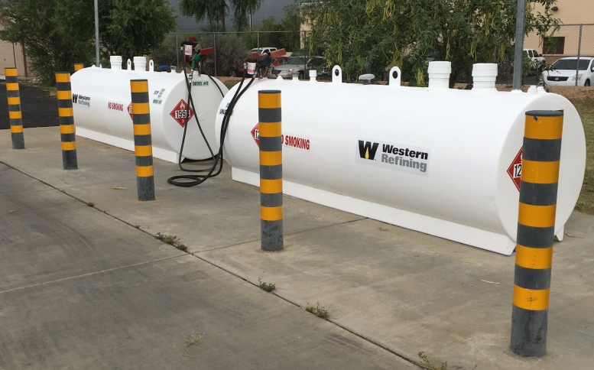

Combustible Waste

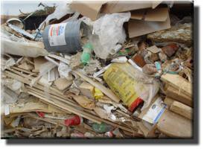
Combustible waste shall not be allowed to accumulate on any site except in approved containers. Waste material shall be removed from the building on a daily basis. Combustible debris, waste material, or trash shall not be burned on the construction site.

Fire Extinguishers

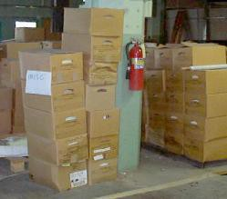

Fire extinguishers sized for not less than ordinary hazard, classified at least
2-A: 10-B: C and containing at least 4.5 pounds of dry chemical agent, are required in buildings under construction, alteration or demolition at each stairway on all floor levels where combustible materials have accumulated, as well as in every storage and construction shed. Travel to a fire extinguisher should not exceed 75’.

Extinguishers shall be installed in plain view in an accessible location, and away from hazardous areas. Additional extinguishers shall be provided where special hazards exist.

Fire Extinguishers shall be serviced and tagged by a reputable fire service company on an annual basis, or immediately after the unit has been fired.

Heaters
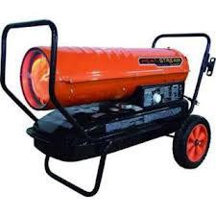
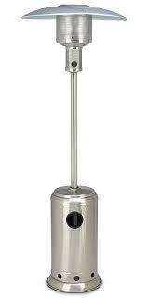

All heaters used in structures must be designed and approved for inside use. Heaters shall not be used in areas where they will create a hazard. Adequate ventilation must be provided for fuel burning heaters. Heaters must be turned off, moved a safe distance from any structure, and allowed to cool before fueling.

Asphalt Kettles

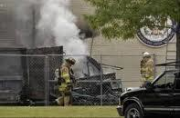
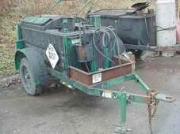

Asphalt (tar) kettles and pots shall not be used inside or on the roof of a building or structure. Kettles shall not be located within 20 feet of any combustible material, combustible building surface, or any building opening, and within a controlled area identified by the use of traffic cones, barriers or other approved means.

Roofing kettles and operating asphalt (tar) kettles shall not block emergency escape routes, gates, roadways or entrances. There must be an attendant within 100 feet of an operating kettle who is knowledgeable of these types of operations and hazards. The attendant shall have the kettle within sight during operation. Ladders or similar obstacles shall not form a part of the route between the attendant and the kettle.
A portable fire extinguisher with a minimum 40-BC rating shall be located within 25 feet of each kettle being utilized and an additional minimum 3A:40-BC rated fire extinguisher shall be on the roof being covered.

Hot Work

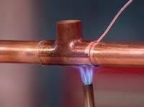
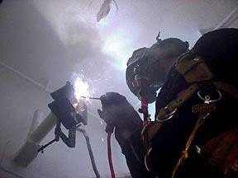

Any person using a torch or other flame-producing device for removing paint, sweating pipe joints, applying roofing materials, or any other process requiring an open flame device in any building or structure shall provide one approved fire extinguisher (minimum size 2A:20-B:C) within 30 feet. Hot work areas shall not contain combustibles, or shall be provided with appropriate shielding to prevent sparks, slag or heat from igniting exposed combustibles.

In all cases, a fire watch shall be maintained in the vicinity of the operation for no less than one-half hour after the torch or flame-producing device has been used. The individuals responsible for performing the hot work and individuals responsible for providing the fire watch shall be trained in the use of portable fire extinguishers.

Knox Box

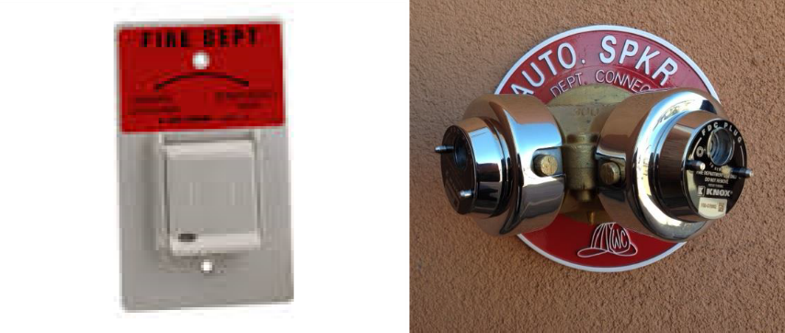

A Knox box, padlock, key switch, or other Knox devices may be required. Please take the following steps:

- In general, the Knox box shall be located adjacent to the main entrance, or in the area of the door for which the box is being provided (such as an owner’s room or fire riser room). Knox boxes shall be installed in an approved location above grade on the latch side of the door. More than one Knox device may be required due to distances and number of buildings.

- Required Knox box or Knox device locations shall be noted on the approved plans. If not, please coordinate with your Fire Inspector regarding location and number of devices required. Once approved, the applicant shall obtain a Knox Company order form from the Rincon Valley Fire District, Fire and Life Safety Division, by calling 520- 647-3760 to authorize the purchase or submit application online at www.knoxbox.com.

- Keys are locked into the Knox device(s) by the Fire Inspector.

For security purposes, it is highly recommended that wall-mounted boxes be recess mounted. Early attention to this requirement will allow appropriate construction decisions to be made to facilitate the installation.

Automatic Gates General Notes

- The automatic gate operator(s) and/or parking barrier arm(s) are to be equipped with battery backup.

- Rincon Valley Fire approved Knox Box key switch shall be used for 24-hour Fire District access. The emergency key switch, when activated, shall by-pass any occupant control and loop systems. When activated, the gate will remain in the open position until de- activated by the Fire District. The gate will resume normal operation only when the key switch has been deactivated.

- The key switch shall open both the entrance and exit gate(s) when gate(s) are in close proximity to each other.

- The Knox Box key switch shall be mounted at five and one-half (5-1/2) feet from grade. (location must be shown on plan)

- The key switch shall be located below a sign labeled “FD ACCESS”. The sign shall be 8 by 4 inches with 0.080 thickness aluminum with round corners. The sign face shall have a white 3M diamond-grade reflective sheeting (3990 series VIP type IX) applied as a background.

- For all split driveway access points, clear openings as shown on plans shall be a minimum 20 feet clear width for entrance and 16 feet clear width or larger on all exit drives.

- Gate operator(s) shall open at a rate of one (1) foot per second. Parking barrier arms will open or clear in approximately two seconds.

- Preemption device shall be installed on all multi-family dwellings including single-family gated communities and multi-family gated communities serving three or more residences per GRFD installation requirements.

- Electric gate operators, where provided, shall be listed in accordance with UL325 (Standard for Door, Drapery, Gate, Louver and Window Operators and Systems). Gates intended for automatic operation shall be designed, constructed and installed to comply with the requirements of ASTM F 2200 (Standard Specification for Automated Vehicular Gate Construction).

VEHICLE ACCESS GATE PLAN SUBMITTAL GUIDELINES

Gates

Minimum of 20-feet wide, clear access opening on entrance points and
16-feet wide on exit access points

Turning radius shall comply with American Association of State Highway and Transportation Officials (AASHTO) WB-50 turning radius and RVFD standards

Automatic Gates

A Fire Department approved Knox Switch is located no higher than five and one-half (5- 1/2) feet above final finished grade on entrance and exit sides of gates.

Emergency Gate Switch will fully open both the entrance and exit gates within 15 seconds of activation and remain in the open position until closed by operation of the electrical control device.

A sign plate reading “FIRE DEPT ACCESS” shall be installed at, but no more than 12 inches from the emergency gate switch. The sign shall be a minimum of 4 by 8 inches, reflective background with 0.080 thickness aluminum.

Upon power failure gates shall fail in the open position. Battery backup shall be installed on entrance and exit gates to allow the gate to operate at least one time.

Residential/multifamily gate will open on battery backup during loss of power and remain open until the power is restored (fail safe).

Commercial/industrial properties remain closed until the emergency gate switch is activated, then open on battery backup (fail secure).

Activated access gate shall open at a rate of one (1) foot per second.

All multifamily housing developments including single-family homes (five (5) or more) shall have preemption devices on each gate

Manual Gate:

All manual fire apparatus access gates shall use an approved padlock as a locking mechanism

ACCESS REQUIREMENTS FOR PREEMPTION DEVICES

Preemption devices shall be installed on all Entrances and Exits of automatic gated communities, apartments, condominiums, town homes, or when required by the RVFD Fire Marshal.

Minimum Standards for Detector Installation (varies on grade)

- Detectors shall be mounted eight (8) to ten (10) feet from grade Detectors shall be located behind the access gate (property side)
- Detectors shall be mounted on a four (4) by four (4) inch metal post, not on guidepost
- Post shall be cemented 18 inches below grade
- Detectors shall activate 150 feet from gate (Site View)
- Each gate shall have two (2) approved individual detectors or an approved dual strobe switch
- Detectors shall point toward the approach and exit path of the emergency vehicle
- Detectors’ sight path shall be free of visual obstructions such as signs, covered parking canopies, and vegetation
- Individual detectors shall be mounted together with the power module in a dual detector mounting box, or with an approved dual strobe switch

NOTE: Detectors shall only be photoelectric sensors

Siren operated sensors are prohibited

Each gate shall be provided with TOMAR, 3M or equivalent photoelectric sensors compatible with RVFD equipment

Knox Key switches shall be provided as a manual backup

The entrance Knox switches shall be located above the residence’s keypad, five and one-half (5- 1/2) feet above grade, with the detectors

The exit Knox Key Switch shall be located on the four (4) by four (4) inch preemption post, recessed five and one-half (5-1/2) feet above grade, with the detectors

RVFD approved “No Parking Signs” are bolted onto each side, back-to-back, of the gate. Signs have a reflective background and are made of .080 thickness aluminum

A sign that identifies the location of the property’s primary entrance shall be bolted on the street side of the fire apparatus gate

Electrical Inspection And Approval
MUST BE OBTAINED FROM THE BUILDING SAFETY DIVISION PRIOR TO
FIRE DISTRICT FINAL INSPECTION

GATE INSTALLATION AND MODIFICATION SHALL BE SUBJECT TO FINAL FIRE INSPECTION AND APPROVAL

Fire Lane Signs
When required, approved signs, curb markings or other approved notices shall be provided for Fire Apparatus access roads. Their location should be shown on the approved plans. If fire lane signs are not shown, please consult with your Fire Inspector for assistance in locating the signs.

All signs are to be installed perpendicular to the road and facing the direction of travel and may be required to be double sided.

Addresses

Approved address numbers shall be visible from the street, mounted on the building or on a roadway monument. The building and suite numbers must be posted at time of Certificate of Occupancy (See Pima County Addressing Code).

WARMING FIRES

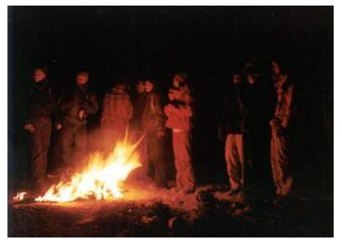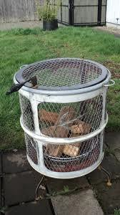

Warming fires at construction sites shall comply with the following:

- No warming fires shall be ignited or maintained unless the fire is contained in an approved waste burner located at least 25 feet from any structure.

- An approved waste burner is a 30 or 55-gallon metal drum, intact, with a spark arrester, constructed of iron or heavy wire mesh with openings no larger than one-half (1/2) inch.

- The fire must be attended at all times by a competent person who shall have a minimum 5/8-inch diameter garden hose pre-connected to a reliable water supply or a 2-A:10-B:C fire extinguisher. This means somebody must be specifically assigned to attend the fire. It is not permissible to leave the fire unattended. The fire must be completely extinguished before it can be left unattended.

- The warming fire shall be extinguished when the burning of material causes or creates dense smoke or odor.

- All burning shall meet the requirements of the Pima County Health Department Division of Air Quality. You must check daily to see if it is permissible to burn.

The Fire Marshal may prohibit any and all fires when deemed hazardous

Storage and Use of Flammable Liquids

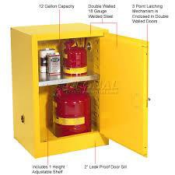
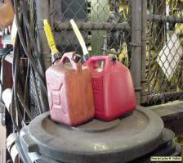

A FIRE PERMIT may be required for the storage or use of more than five (5) gallons of flammable liquids, or 25 gallons of combustible liquids, and shall be in an area approved for flammable/combustible liquid storage. Check with your Fire Inspector.

The storage of all flammable liquids must be in safety containers designed for their use. Flammable liquids shall not be stored in buildings under construction. All containers must be labeled with the liquid they contain and the words:

FLAMMABLE – KEEP FIRE AND FLAME AWAY - KEEP 50’ FROM BUILDINGS

COMPRESSED OR LIQUEFIED GASES, STORAGE OR USE

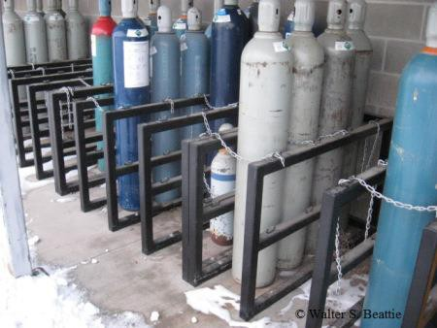
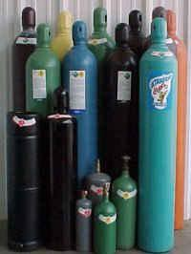

Cylinders, valves, regulators, hose and other apparatus and fittings for oxygen shall be kept free from oil and grease. Oxygen cylinders, apparatus and fittings shall not be handled with oily hands, oily gloves, greasy tools or equipment.

Acetylene gas shall not be piped unless using approved cylinder manifolds and connections. Cylinders shall be located away from the hot work area to prevent them from being exposed to radiant heat or due to sparks, slag, or misdirection of the torch flame (See Section 8, Hot Work).

All cylinders shall be secured to prevent dislodgement and access by unauthorized persons.

GENERATORS UTILIZING FLAMMABLE OR COMBUSTIBLE LIQUIDS
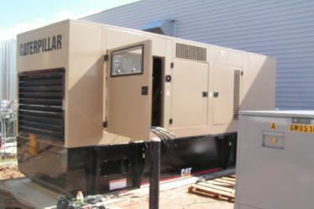

A permit may be required to be obtained from RVFD when proposing to install a temporary/permanent generator having a fuel tank using flammable liquids in excess of 10 gallons, or combustible liquids in excess of 60 gallons.

Prior to installation, a permit application, site plan showing distance from buildings, property lines, public right-of-ways and grounding specifications shall be submitted to RVFD along with any required fees prior to installation.

An inspection and approval of the installation of the generator will be required before operation of the generator.

Annual generator inspection reports will be required and will need to be produced upon request by RVFD.

Fire Inspection and Testing

APPROVED PLANS AND PERMITS MUST BE ON THE JOB SITE

DURING CONSTRUCTION AND TESTING

- All requests for acceptance testing and fire inspections shall be made by calling the Rincon Valley Fire District, Fire and Life Safety Division at (520) 647-7102 at least two (2) business days in advance. It may be necessary to leave a message. Please be prepared to give the following information:

  - Pima County Permit number
  - Exact address including suite number
  - Name of project/occupancy
  - Purpose for requiring an inspection
  - A call back phone number, name of company & person’s name

You will receive a confirmation of the date and time slot (morning or afternoon) for the scheduled inspection.

- Approved plans bearing a red fire district approval stamp shall be on the job site at all times. No inspections or tests will be conducted without them. The front page as well as the fire protection sheets will bear a red fire district stamp. Mirror plans, plans depicting multiple options and plans that do not accurately reflect the location of water service, riser locations etc. will not be approved and/or may lead to an inspection failure due to construction not conforming to approved plans.

- Examples of separate plan submittals for fire permits, referred to as deferred submittals, include:
- FIRE SPRINKLER MONITORING
- FIRE SPRINKLER SYSTEMS
- FIRE ALARM SYSTEMS
- KITCHEN HOOD EXTINGUISHING SYSTEMS

Note: Deferred submittals are prohibited for tenant improvement projects

- Fire protection systems shall be pre-tested by the contractor and all corrections made prior to scheduling an acceptance inspection.

The permit fee is calculated to include primary tests or inspections. An additional charge equal to the original permit fee, based on the fee recovery schedule, will be charged for excessive inspections on the same item. Scheduled inspections not canceled at least two (2) hours before the scheduled test will be counted as an inspection with additional fees possible.

- Acceptance test inspections are for the system covered by the permit. This may include the entire building, only a portion of the building, or a piece of equipment. If it is necessary, or you choose to test a single system in phases requiring more than the allotted inspections for the permit, additional inspection fees may apply. It is recommended you consult with your inspector and discuss an inspection strategy.

- Unless otherwise approved in writing through the alternate means and methods section of the fire code, all systems shall be designed and installed in accordance with the GRFD adopted editions of codes and standards. These are not always the most current edition of codes or standards available on the common market. It is the contractor’s responsibility to comply with the proper adopted codes and standards.

- Please contact the RVFD Fire and Life Safety Division at (520) 647-3760 or your assigned Fire Inspector for a list of the current amendments.

NOTE: If your project requires your installers to deviate from the approved set of plans, an as built must be submitted to the RVFD prior to scheduling the appropriate inspection. Failure to do so may result in an inspection failure with additional fees.

Our inspectors have been instructed to inspect to the approved plans and not approve installations that do not comply with those plans. Inspectors do not have authority to approve field changes that are not reflected on an approved plan. Only minor changes may be field approved.

Fire Sprinkler Systems

Automatic fire sprinkler NFPA 13 and 13R systems shall be installed or modified by a contractor licensed (L-16 or C-16) to perform such work by the State of Arizona Registrar of Contractors (ROC), and/or who also holds a current valid permit from RVFD to conduct such work within the District and approved boundaries.

Automatic sprinkler risers for 13D systems shall be located in the wall cavity with an access panel on the outside of the wall. No risers shall be exposed to the elements.

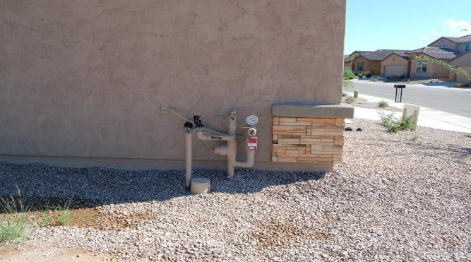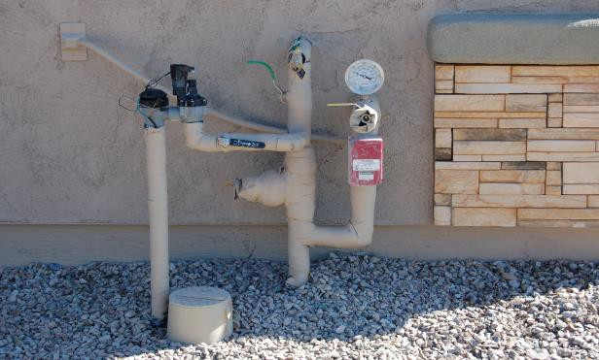

**OUTSIDE RISERS-NOT APPROVED**.

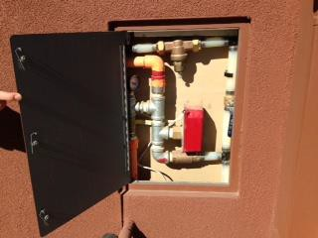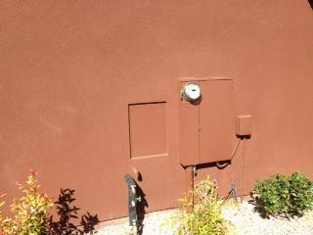

**APPROVED **

Fire Pumps and Fire Risers and Riser Rooms

Fire pump and automatic sprinkler system riser rooms shall be located in a dedicated room and have a door directly accessible from the exterior of the building.

The room shall be designed with adequate space for all equipment necessary for the installation, as defined by the manufacturer, with sufficient working space around the stationary equipment to allow for the exchange of parts. The key for the door shall be located in a KNOX after-hour key-box. The key-box shall be affixed to or recessed into the wall on the door handle side of the riser room door.

Fire Pump and automatic sprinkler system riser rooms shall be provided with door(s) and an unobstructed passageway large enough to allow removal of the largest piece of equipment.

Each fire pump and fire sprinkler riser room door shall be identified by a permanent weather resistant sign. The sign face shall be 12 inch by 12 inch minimum with block letters of six (6) inch height minimum, ½” stroke in a color contrasting with the door color.
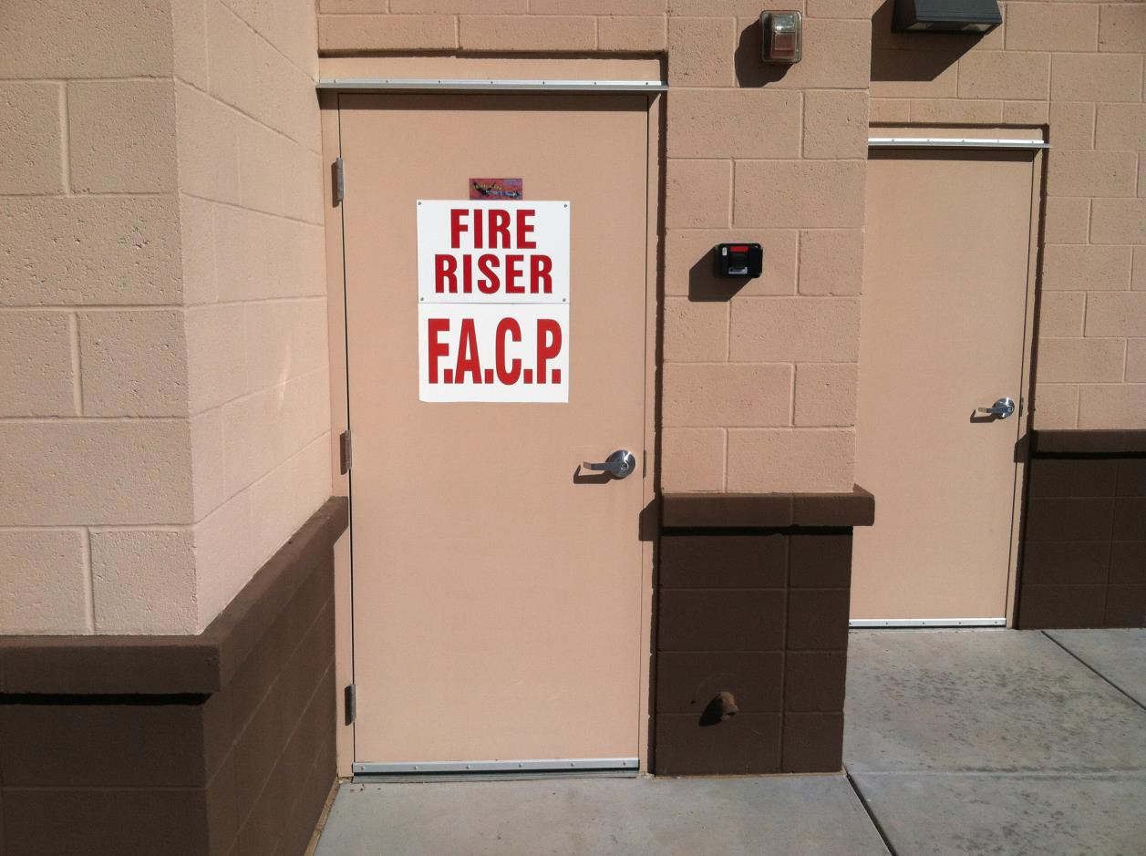
FIRE
RISER

12”

12”

The floor shall be kept at least one (1) inch away from the riser pipe. A mastic material is allowed to be used between the concrete floor and pipe to keep out moisture and bugs.

The main drain, inspector’s test and any other orifice shall terminate on the exterior of the riser room.

Fire Department Connections

Fire Department Connections (FDC’s) fire sprinkler systems shall be a Siamese 2½ ” female swivels with National Standard Threads (NST). FDCs shall be located a maximum of 200 feet from the nearest fire hydrant. The fire hydrant and FDC shall be on the same side of the drive entrance to prevent access obstruction when practical. The location of fire department connections shall be approved by the GRFD Fire Marshal.

FDC’s for NFPA 13R sprinkler systems shall consist of a single female port swivel with one 1½” National Standard Thread (NST) connection.

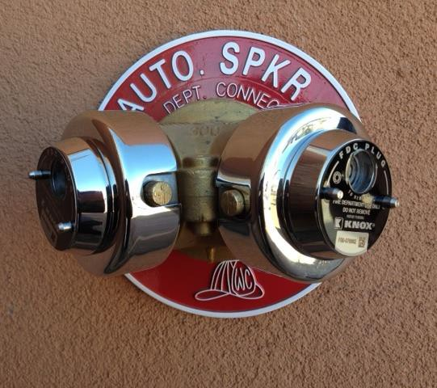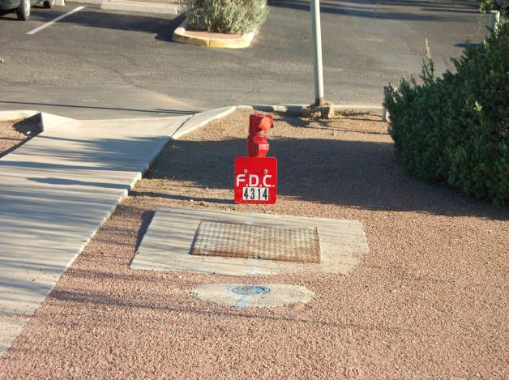

12"

3" X %"
LETTERING (TYPICAL FOR ALL SIGNS)

12 “
1 7 9
16
" X 32"
LETTERING

FDC

All Fire Department hose connections and standpipe hose connections for Fire Department use shall consist of two 2½” NST connections, unless hydraulically calculated to reduce to one connection. No hose shall be attached to the Fire Department Hose Stations. Connection ports shall be protected with Knox 2½” locking FDC plugs with Swivel-Guards.

Each Fire Department Connection (FDC) shall be identified by a permanent weather resistant sign. When the system supplied by the FDC does not supply the entire building or supplies multiple buildings, signs shall identify the building areas supplied by the FDC. The fire department connection sign shall identify the building address or area, where necessary and the type of system the FDC supplies.

Automatic fire sprinkler systems shall be supervised by an approved central, proprietary or remote signal station service in all occupancies that are NFPA 13 or 13R compliant.

Minimum inspections required prior to approval of new sprinkler systems and final fire approval:
- Underground Piping Hydrostatic Two (2) Hour Pressure Test
- Riser Flush
- Overhead fire sprinkler intermediate
- Overhead fire sprinkler final
- Final fire

Underground Piping Hydrostatic Two-Hour Pressure Test

- Systems shall be pre-tested by the contractor
- Systems shall be tested hydrostatically at 200 psi for two (2) hours (pressure test gauge at lowest end of the system being tested)
- All joints must be fully exposed (Pipe center loading is acceptable)
- Thrust blocks (kickers) or other approved mechanical restraints must be in place and visible
- Where ductile iron pipe is used, all pipe and fittings shall be wrapped
- Where C-900 pipe is used, a tracer wire or metallic warning tape must be added in accordance with manufacturers installation recommendations
- Flushing of the main shall be conducted in the presence of a fire inspector after approval of the underground pressure test. Water shall flow through the pipe until clear water appears
- All check valves must be in their full open position per AWWA standards
- NFPA #13 certificate form, “Contractors Test and Materials for Underground Piping” shall be completed by the installing contractor, signed and presented to the fire inspector during the acceptance testing.

IMPORTANT NOTE

It is highly recommended you consult with your fire and building inspectors along with the water purveyors to determine who witnesses and approves the installation and who conducts chlorination and bacteria tests of underground water lines. The installing contractor shall coordinate the acceptance testing required by RVFD and other inspectors.

Overhead Piping Hydrostatic Two (2) Hour Pressure Test and Rough-in Inspection

- Systems shall be pre-tested by the contractor
- The system shall be tested at 200 psi for two (2) hours with all system piping visible from floor level
- Piping that is concealed, obstructed or otherwise hidden by sheetrock; ceiling tiles; or other materials will be required to be exposed prior to testing or inspection. The piping systems may be partially concealed only with the approval of the Fire Inspector
- You will be required to remove any obstructions to allow viewing of the complete piping system before an inspection will be conducted
- NFPA #13 certificate form, “Contractors Test and Materials for Aboveground Piping” shall be completed by the installing contractor, signed and presented to the fire inspector during the acceptance testing

Final Sprinkler Inspections

The completed Contractors Material and Test Certificates shall be provided to the Fire Inspector prior to final inspection which includes:
- Visual inspection of the entire system (drywall and ceiling panels shall be in place)
- Exterior bell tests, including approved third party monitoring, with the installation of over 20 heads
- A separate permit from the Fire Department is required for the monitoring of the sprinkler system. The Permit must be obtained prior to testing
- A hydraulic calculation data plate (NFPA 13) must be installed on all calculated systems. Stamped or engraved metal or rigid plastic plates are required. The use of magic markers, embossed tape labels, or metal impression labels is NOT allowed
- Sprinkler head box(es) shall be properly installed, stocked with sprinkler heads, wrench, and a NFPA 25 booklet. The number of heads and boxes shall be in accordance with NFPA 13
- Supervision of all valves
- System shall be fully operational
- All signage shall be installed
- Main drain test witnessed by Fire Inspector
- Inspectors test and timed water flow alarm test witnessed by a Fire Inspector
- Pressure drop test across the backflow device, if installed
- Other tests or inspections that may be required

Fire Alarm Systems

- All tests shall be requested by the contractor named on the fire alarm permit
- The entire system shall be fully installed and pre-tested prior to scheduling a witness of the test
- The permit fee is calculated to include primary tests or inspections. An additional charge, will be assessed for excessive inspections on the same item. Scheduled inspections not canceled prior to 2 hours before the scheduled test will be counted as an inspection.
- Tests performed after normal duty hours will be charged the current scheduled rate for a minimum of two (2) hours
- All control panels, initiating and signaling devices, power supplies and auxiliary devices shall be tested in the presence of the inspector
- All devices shall be tested in accordance with manufacturers' recommendations. It shall be the responsibility of the installer to provide and be ready with the equipment and supplies necessary, including heat guns, approved canned smoke, ladders and other necessary devices required for testing of the entire system
- A copy of the approved plans shall be permanently maintained at the fire alarm panel.
- An approved simplified floor plan of the areas served by the alarm panel shall be posted near the enunciator panel. Zone descriptions and /or devices shall correspond with the floor plan. Consult with the fire inspector
- A Certificate of Completion and an Inspection and Testing Form (NFPA 72) shall be completed and provided to the Rincon Valley Fire District prior to acceptance

Kitchen Hood Extinguishing Systems

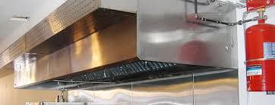
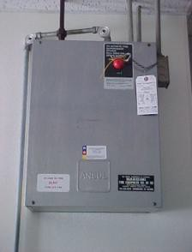

Kitchen hood extinguishing systems shall be installed in accordance with the International Fire Code (IFC), International Mechanical Code (IMC) and the
NFPA Standard #96

The installing contractor shall perform all tests including:

  - All components, including remote manual pull stations, mechanical or electric devices, detectors, actuators, and interlocks, shall be tested for proper operation during the inspection in accordance with the manufacturers' listed procedures
  - Gas cooking appliances shall be connected to gas lines prior to testing
  - Upon activation the system shall shut down fuel and electricity to the appliances under the hood
  - Electric power required for acceptance testing of systems shall be provided by grid power only
  - Upon activation of the system, the makeup air supply to a hood shall be shut down and hood exhaust fans shall continue to run unless shutdown is required by the extinguishing system manufacturer or unless another component of the system requires shutdown per NFPA Standard #96
  - When the building has a fire alarm system, the kitchen hood extinguishing system shall be electronically supervised with alarm signals to the Fire Alarm Control Unit (FACU) and third party monitoring
  - A Class K fire extinguisher is required for UL 300 compliant kitchen hood systems

ALL FINAL TESTING OF FIRE PROTECTION SYSTEMS MUST BE CONDUCTED ON GRID POWER, NOT GENERATOR POWER. TEMPORARY POWER SUPPLIED FROM THE GRID, THROUGH A METER IS ACCEPTABLE.

ALWAYS PRETEST THE SYSTEM PRIOR TO SCHEDULING A FINAL

Certificate of Occupancy

All requests for Fire Final Inspections shall be called in to the Rincon Valley Fire District Fire and Life Safety 520-647-3760, no later than two (2) business days prior to the date required.

Approved plans bearing the Fire Department stamp and all permits must be available at the job site at all times from the start of construction through final inspection. The Fire Inspector will provide you an electronic copy of each inspection report conducted at your project. Keep this paperwork on the job site. You may be required to provide documentation that an inspection has been completed and it is expected that you will be able to provide the paperwork at the final inspection.

In order to obtain Fire District sign off on the Final Fire Inspection, the following minimum conditions must be met:

- All automatic fire protection and life safety systems and equipment including sprinklers, fire alarms, smoke control, emergency lighting, etc. must be installed, tested and in full operation and all RVFD permits shall be signed off. If third party monitoring is required it shall be operational.

- All occupancies shall have proper fire extinguishers required for the occupancy. Consult with your assigned Fire Inspector.

- All paving must be completed and signage must be installed. Addresses must be posted and, if required, a graphic directory must be installed. Separate building identification, if required, shall be installed. Consult with your Fire Inspector.

Summary

APPROVED PLANS & PERMITS MUST REMAIN ON THE JOB SITE DURING CONSTRUCTION & TESTING
- ALWAYS PRETEST YOUR SYSTEM BEFORE SCHEDULING AN INSPECTION
- IF UNSURE OF A REQUIREMENT, CONTACT YOUR INSPECTOR OF RECORD

To Schedule an Inspection Call:
(520) 647-3760

